Practical 10
1. Aim
To understand the basic concepts of VMware vSphere, ESXi, and vCenter Server, set up an ESXi virtualization environment, access the ESXi Host Client from a Windows 11 computer, and create a Virtual Machine (VM) with Ubuntu 20.04.6 Desktop as the guest operating system.

2. Objectives
- To understand VMware vSphere virtualization.
- To understand the role of VMware ESXi.
- To understand the purpose of vCenter Server.
- To install and configure VMware ESXi in a lab environment.
- To access ESXi using its web-based Host Client.
- To understand the vSphere Client/Web Client.
- To prepare an Ubuntu 20.04.6 Desktop ISO for VM installation.
- To create a new Virtual Machine on an ESXi server.
- To configure CPU, memory, storage, network, and CD/DVD resources.
- To install Ubuntu on the newly created VM.
- To verify that the VM is working correctly.

3. Software and Hardware Requirements
Hardware
- Physical computer/server capable of running VMware ESXi.
- CPU with hardware virtualization support.
- Minimum recommended RAM according to the ESXi version and the number of VMs.
- Sufficient local storage for ESXi and the virtual machine.
- Network adapter supported by the selected ESXi version.
- Windows 11 computer for accessing and managing ESXi.
- Network connection between the Windows 11 computer and ESXi host.
Note: ESXi is normally installed directly on a physical server. For a classroom/home lab, ESXi may also be run as a nested virtualization environment if the available hardware and VMware configuration support it.
Software
- VMware vSphere ESXi
- Web browser on Windows 11, such as Microsoft Edge or Google Chrome
- VMware vSphere Client — accessed through a web browser when a vCenter Server is available
- Ubuntu 20.04.6 Desktop ISO
4. Introduction
4.1 VMware vSphere
VMware vSphere is VMware's virtualization platform for running and managing virtual machines and virtualized data-center resources.
It includes technologies for:
- Server virtualization
- Virtual machine management
- Networking
- Storage
- Resource management
- Centralized administration
Two important components are ESXi and vCenter Server.

4.2 VMware ESXi
VMware ESXi is a bare-metal hypervisor.
It is installed directly on a physical server and provides the virtualization layer required to run multiple Virtual Machines on the same physical hardware.
For example:
Physical Server
|
ESXi
|
+--------+-------+-------+
| | | |
VM1 VM2 VM3 VM4
Each VM can have its own:
- Virtual CPU
- Virtual memory
- Virtual hard disk
- Virtual network adapter
- Guest operating system
Broadcom's current ESXi documentation describes interactive installation as one of the installation methods and notes that the installer can be booted from installation media such as an ISO. The installer partitions/formats the selected installation disk, so the target disk must be selected carefully.

4.3 VMware vCenter Server
vCenter Server provides centralized management of VMware environments.
A single ESXi host can be managed directly through its Host Client. When multiple ESXi hosts are used, vCenter Server can provide centralized management through the vSphere Client.
The basic relationship is:

vCenter Server
|
+-----------+---------+
| |
ESXi ESXi
Host 1 Host 2
| |
+----------+ +--------+
| | | |
VM1 VM2 VM3 VM4

5. Understanding the Clients
There are two interfaces relevant to this practical.
5.1 ESXi Host Client
The ESXi Host Client is used to directly manage an individual ESXi host.
It is accessed through a web browser:
https://<ESXi-IP-address>
For example:
https://192.168.1.100
No separate Windows application needs to be installed for the Host Client.

5.2 vSphere Client
The vSphere Client is an HTML5-based web application used to manage vCenter Server and its managed VMware environment.
Therefore, on Windows 11, there is normally no separate traditional "vSphere Web Client" program to install. A supported modern browser such as Edge, Chrome, or Firefox is used to access it.
For a vCenter environment, the access address is generally:
https://<vCenter-FQDN-or-IP>
For this practical, vCenter Server is not required to create a VM directly on a standalone ESXi host. The VM can be created using the ESXi Host Client.

6. Part A — Download/Prepare the Required Software
Step 1: Obtain the ESXi Installer
Obtain the appropriate VMware vSphere ESXi installer ISO from the official Broadcom/VMware software download portal.
Step 2: Prepare the Ubuntu ISO
Download the following Ubuntu ISO:
ubuntu-20.04.6-desktop-amd64.iso
The ISO will later be uploaded to an ESXi datastore and connected to the VM's virtual CD/DVD drive.
The Ubuntu ISO is the guest operating system installer. It is not used to install ESXi.
Therefore, there are two different ISO purposes:
ISO | Purpose
ESXi ISO | Used to install the ESXi hypervisor
Ubuntu ISO | Used to install Ubuntu inside the VM

7. Part B — Install VMware ESXi
Important: Installing ESXi on a physical machine can erase data on the selected installation disk. Use a dedicated lab machine/disk or an approved lab environment.
Step 1: Boot the ESXi Installer
- Connect the ESXi installation ISO to the physical server.

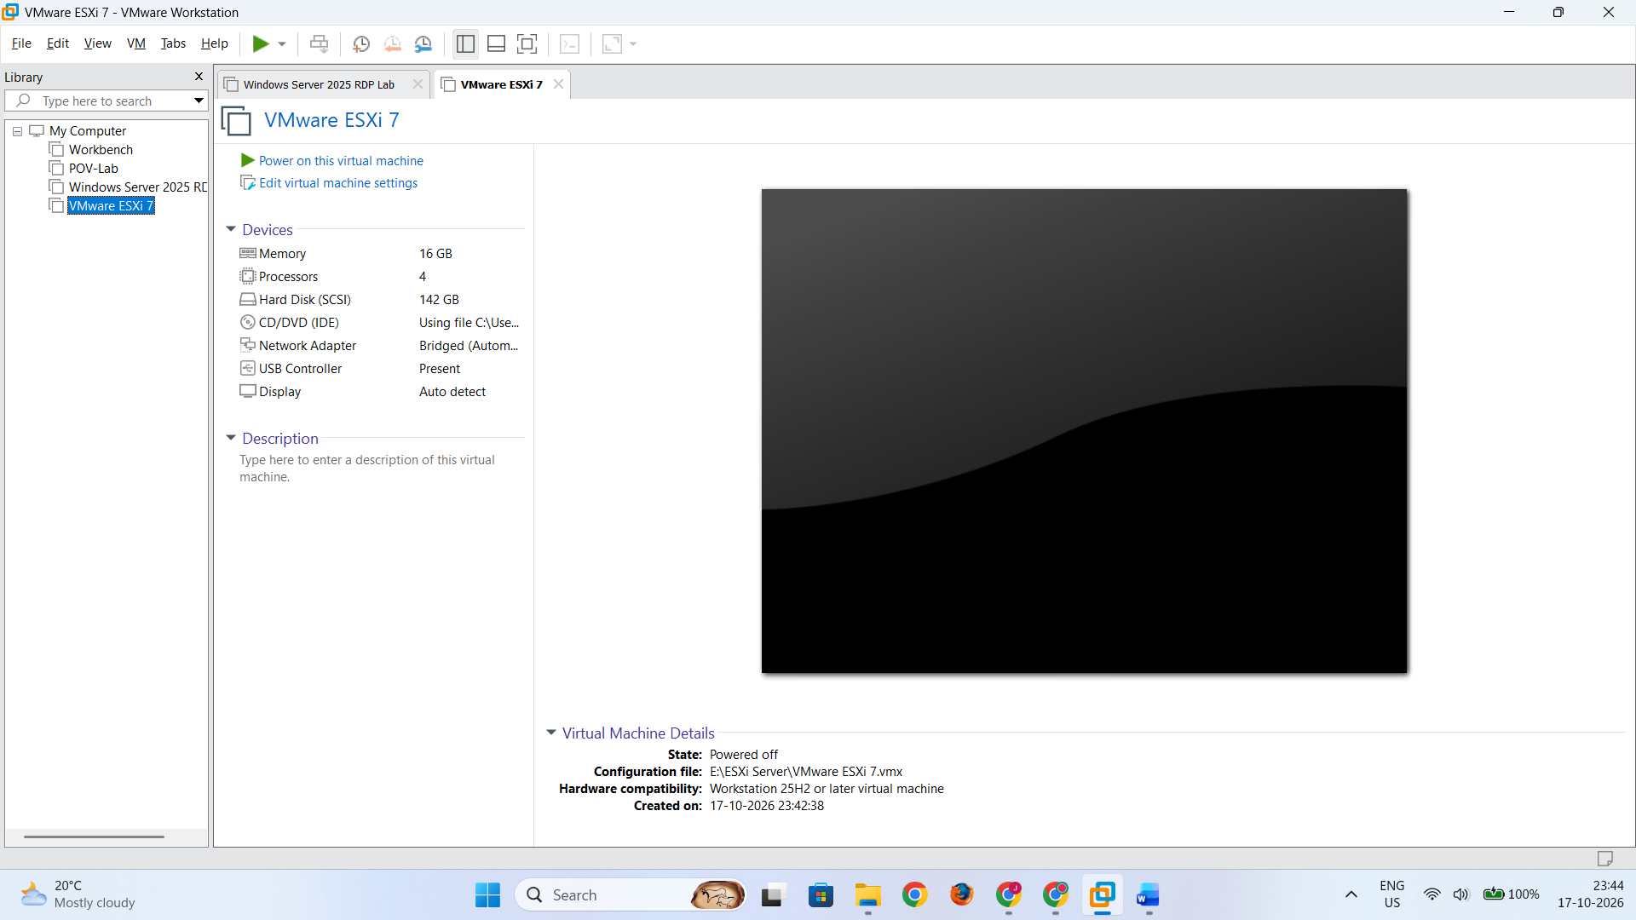
- Boot the server.
- Enter the system's boot menu if necessary.
- Select the device containing the ESXi installer.
- The ESXi installer starts.
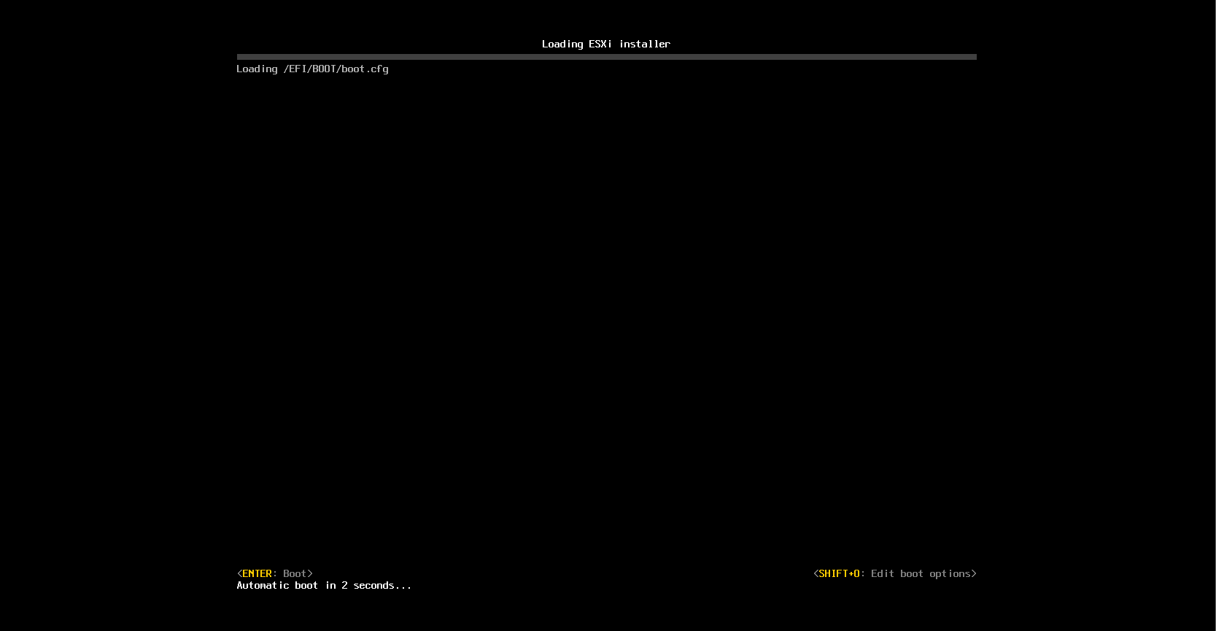
Step 2: Start ESXi Installation

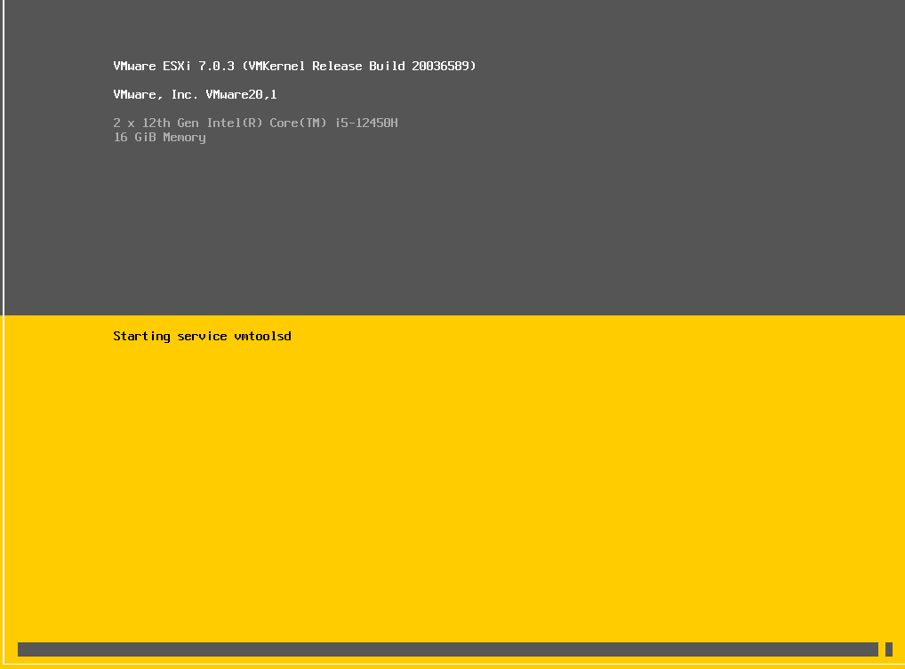
Follow the installation wizard.
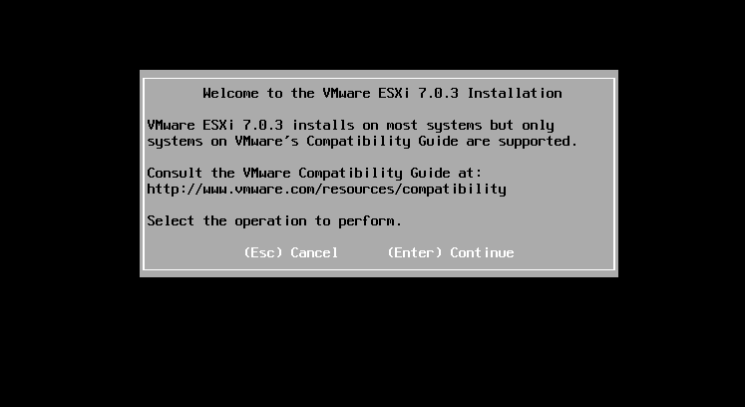

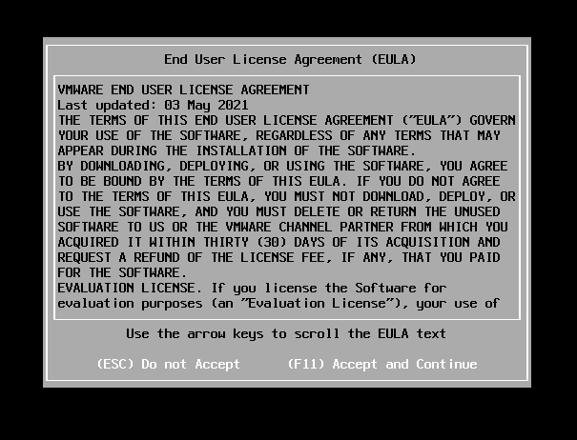
The installer detects the available storage devices.
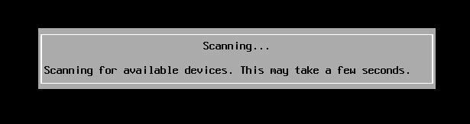
Select the disk intended for ESXi installation.

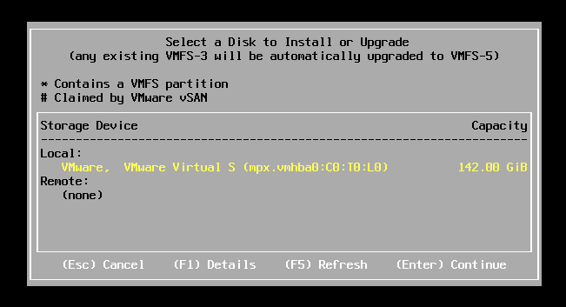
Check the disk carefully before continuing.
The ESXi installer can reformat and partition the selected target disk, potentially destroying existing data.
Step 3: Configure Keyboard Layout
Select the required keyboard layout.
For a standard lab:
Keyboard Layout: US Default
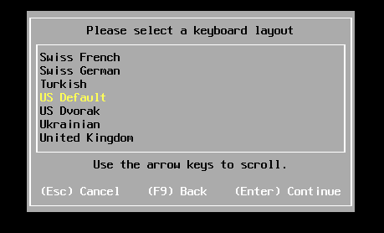
Continue with the installation.
Step 4: Set the ESXi Root Password
Create a strong administrator/root password when prompted.
Example:
Username: root
Password: <lab password>
Do not use the example password literally.
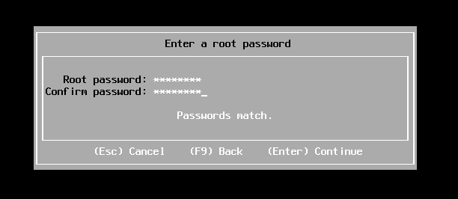
Step 5: Confirm Installation
Confirm that ESXi should be installed on the selected disk.
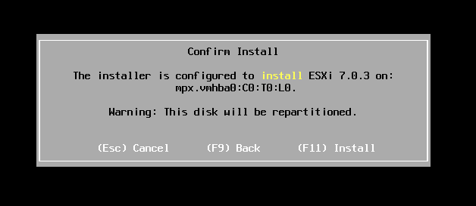
Wait for the installation to complete.

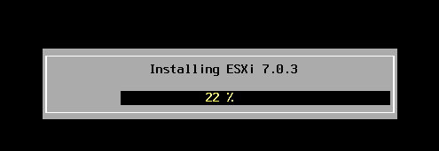
Step 6: Reboot
After installation:
- Remove/unmount the ESXi installation ISO.
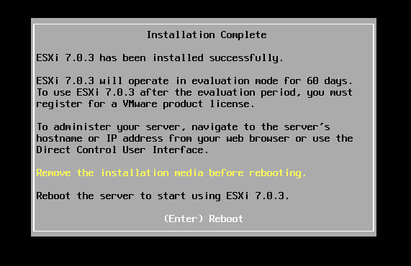
- Reboot the server.
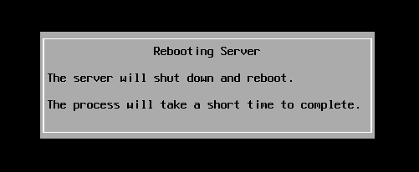
- ESXi starts from the installation disk.
The ESXi Direct Console User Interface (DCUI) should appear.
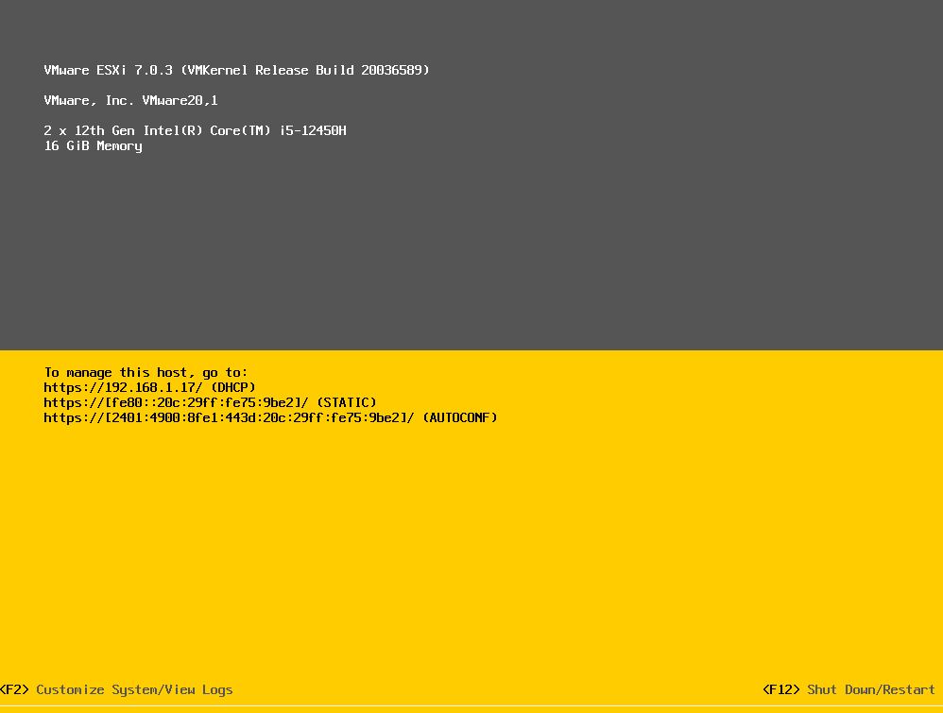
8. Part C — Configure ESXi Networking
After ESXi starts, configure its management network.
From the ESXi Direct Console:
- Press F2.
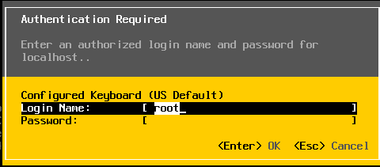
- Log in using the root account.
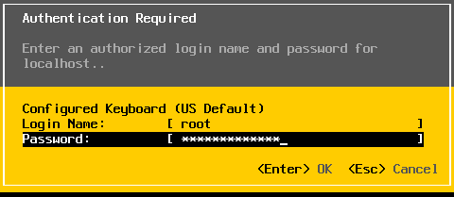
- Open Configure Management Network.
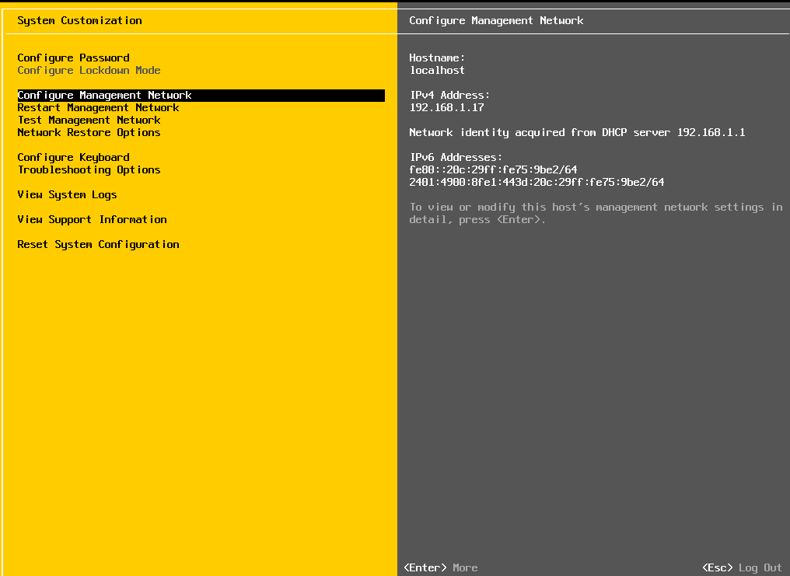
- Configure the appropriate network adapter.
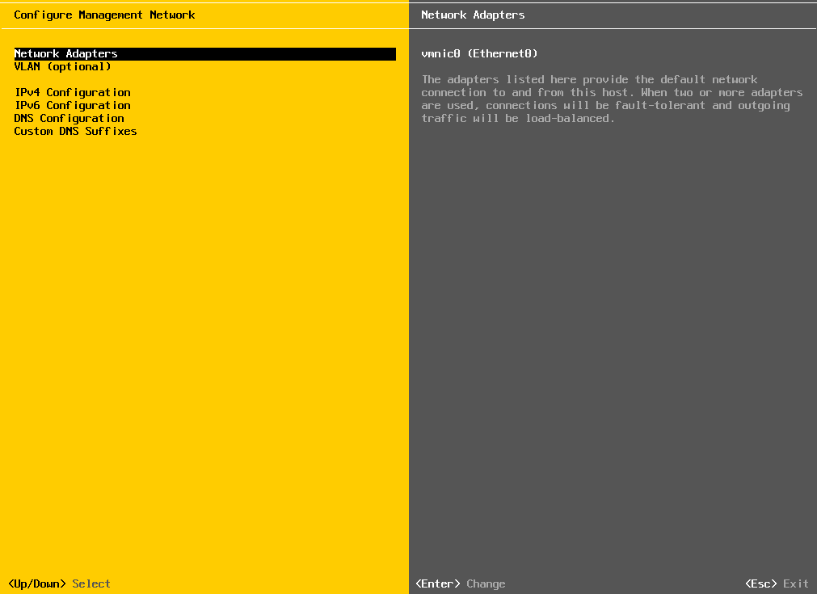
- Configure IPv4 settings.
For a simple lab, an example configuration could be:
IPv4 Address : 192.168.1.100
Subnet Mask : 255.255.255.0
Gateway : 192.168.1.1
These are example values. Use the addressing scheme provided by your lab/network.
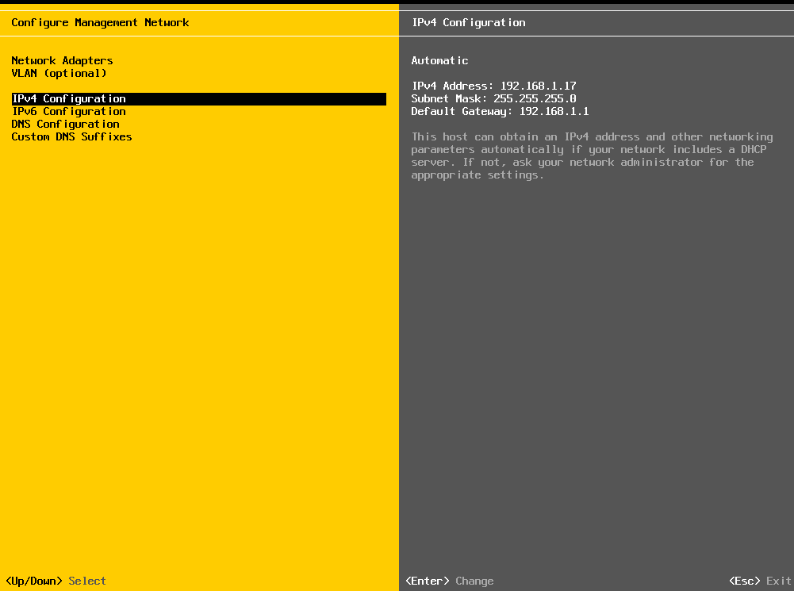
If DHCP is being used, ESXi may receive its IP address automatically.
After changing network settings, restart the management network when prompted.
Record the ESXi management IP address because it will be required from Windows 11.

9. Part D — Access ESXi from Windows 11
Step 1: Open the Web Browser
On the Windows 11 computer:
- Open Microsoft Edge or Google Chrome.
- Enter:
https://<ESXi-IP-address>
Example:
https://192.168.1.100

Step 2: Certificate Warning
The ESXi host may use a certificate that is not trusted by the Windows computer/browser.
A certificate warning may therefore appear.
In a controlled lab environment, proceed to the ESXi login page according to the browser's displayed options.
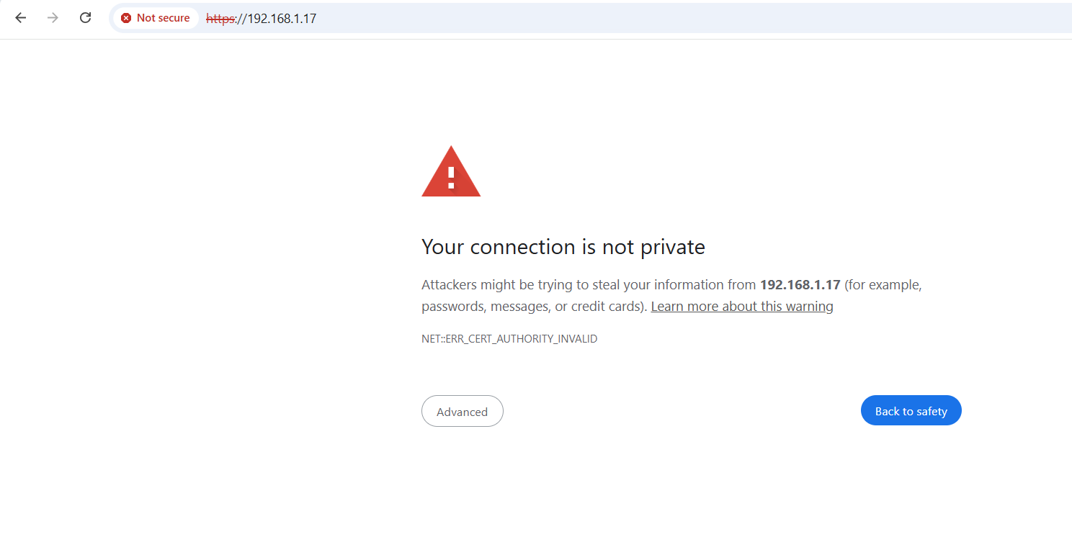
Step 3: Log In
Enter:
Username: root
Password: <ESXi root password>
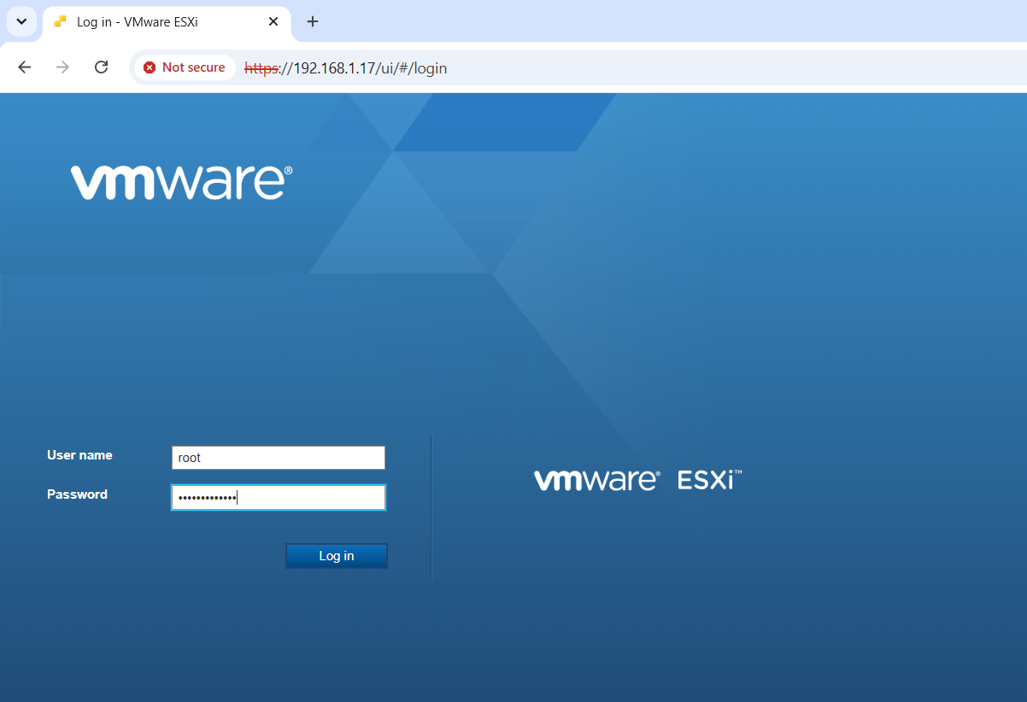
After successful login, the VMware Host Client is displayed.
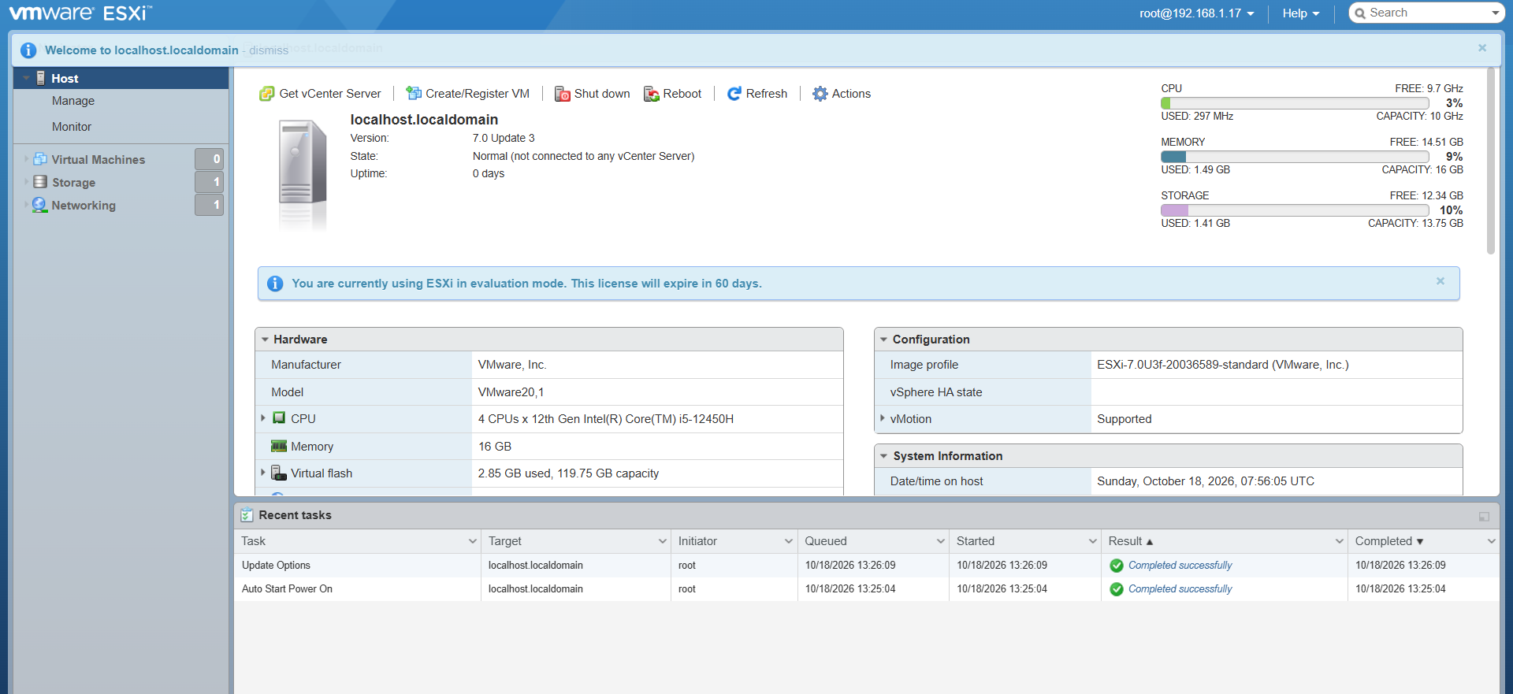
10. Part E — Verify the ESXi Host
From the ESXi Host Client, verify:
- Host name
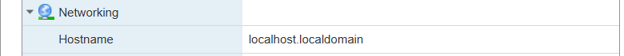
- ESXi version
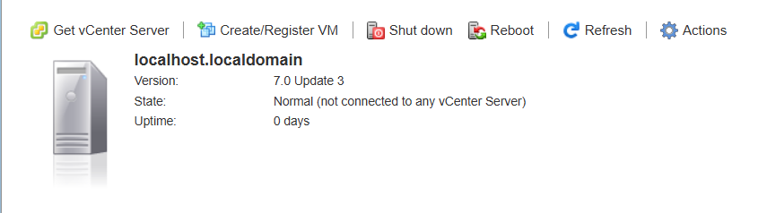
- CPU information
- Memory
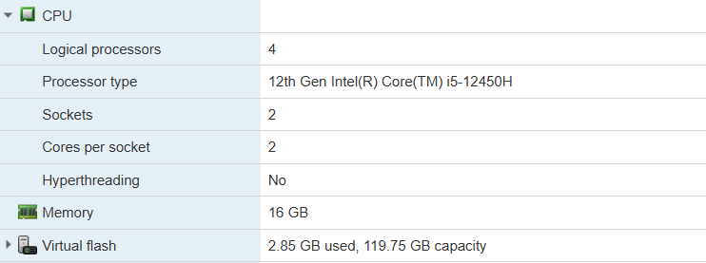
- Storage
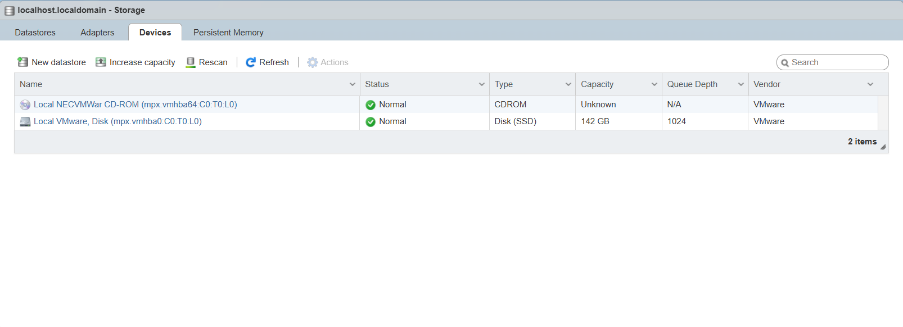
- Network adapters
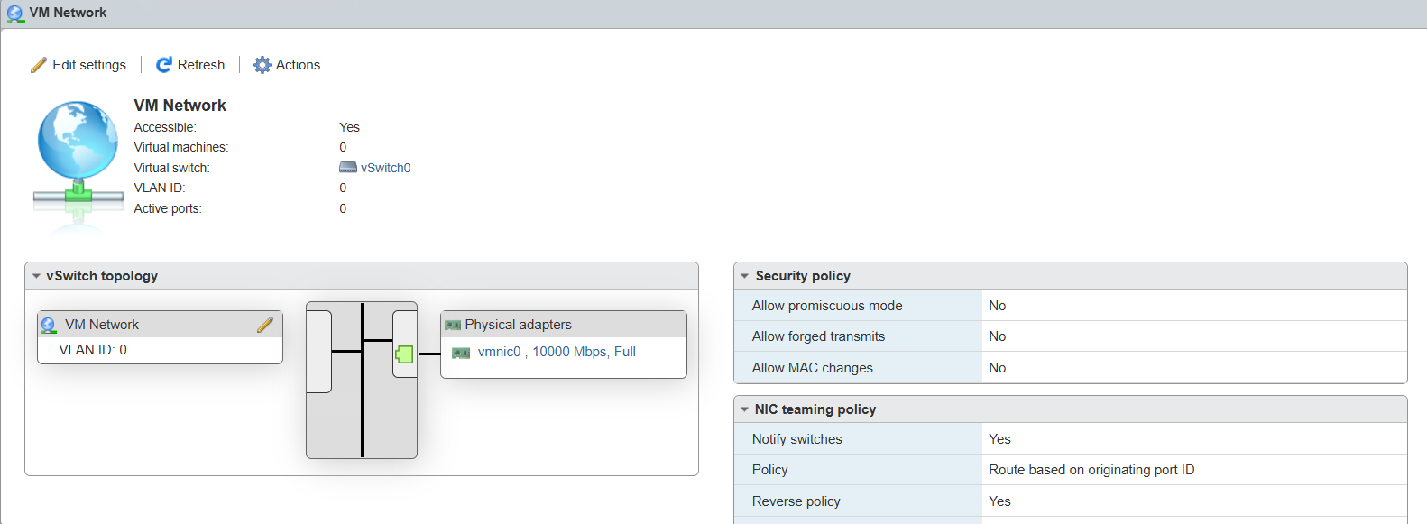
- Datastores
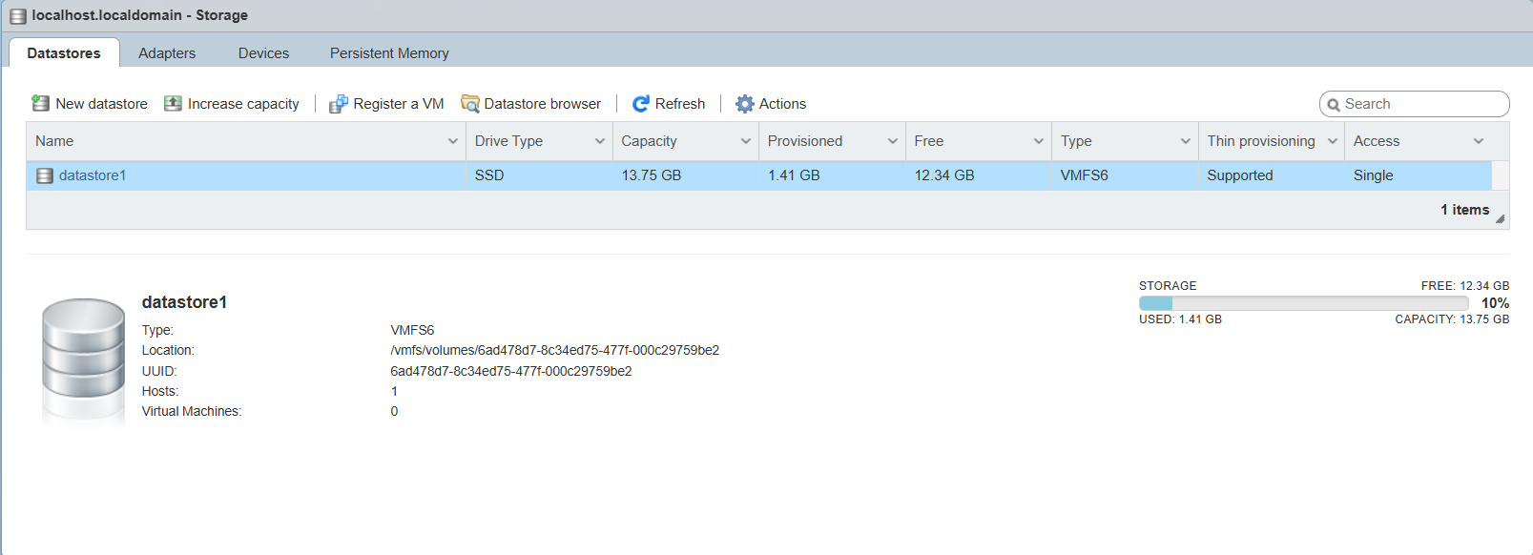
- Virtual machines
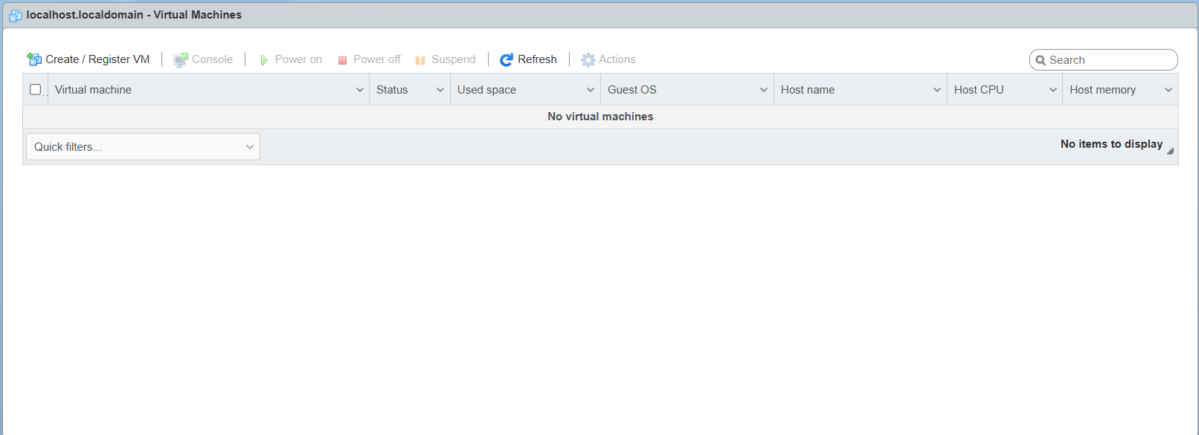
The Host Client provides the interface for managing the standalone ESXi host.

11. Part F — Upload Ubuntu ISO to the ESXi Datastore
Before creating the VM, upload the Ubuntu ISO to an ESXi datastore.
Step 1: Open Storage
In the ESXi Host Client:
- Select Storage.
- Select Datastores.
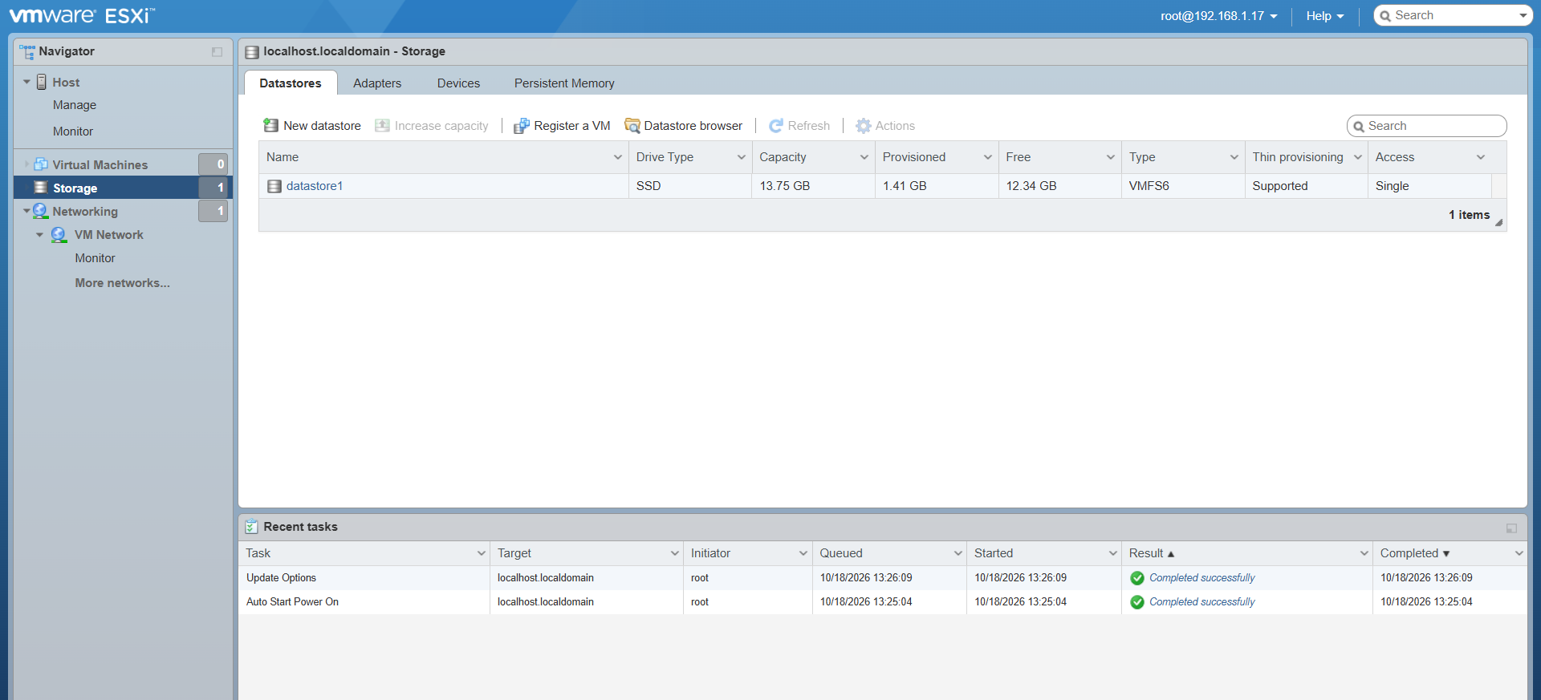
- Select the available datastore.
For example:
datastore1
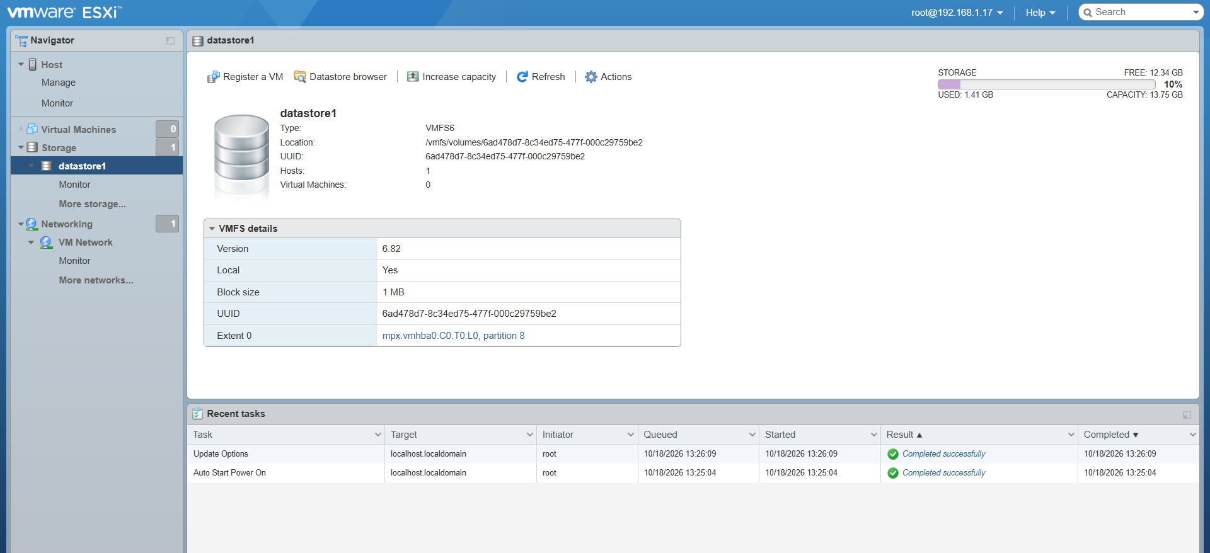
Step 2: Open the Datastore Browser
Open the datastore browser.
Create a folder if desired:
ISO
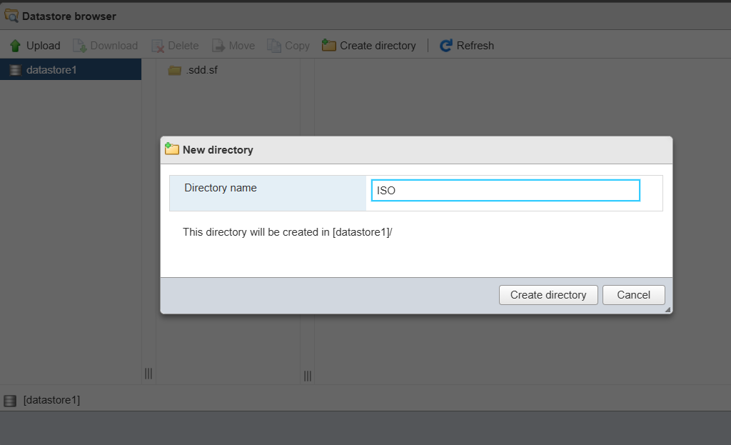
Step 3: Upload the Ubuntu ISO
Upload:
ubuntu-20.04.6-desktop-amd64.iso
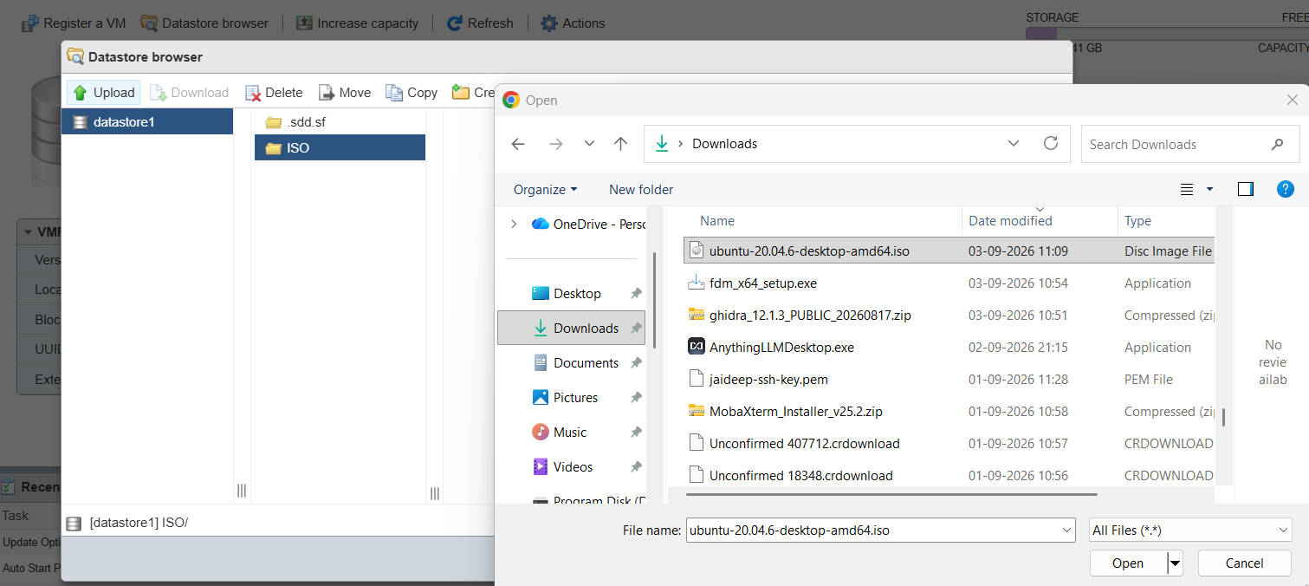
Wait for the upload to complete.
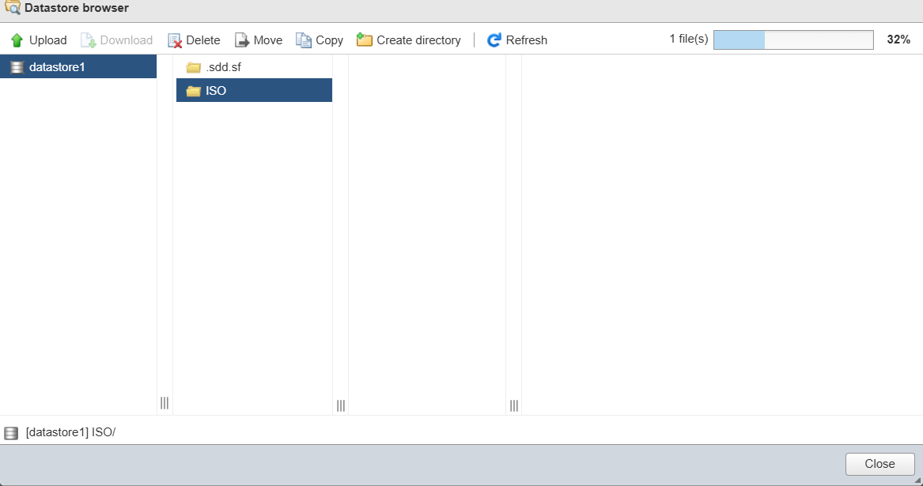
The ISO is now stored on the ESXi datastore and can be connected to the VM's virtual CD/DVD drive.
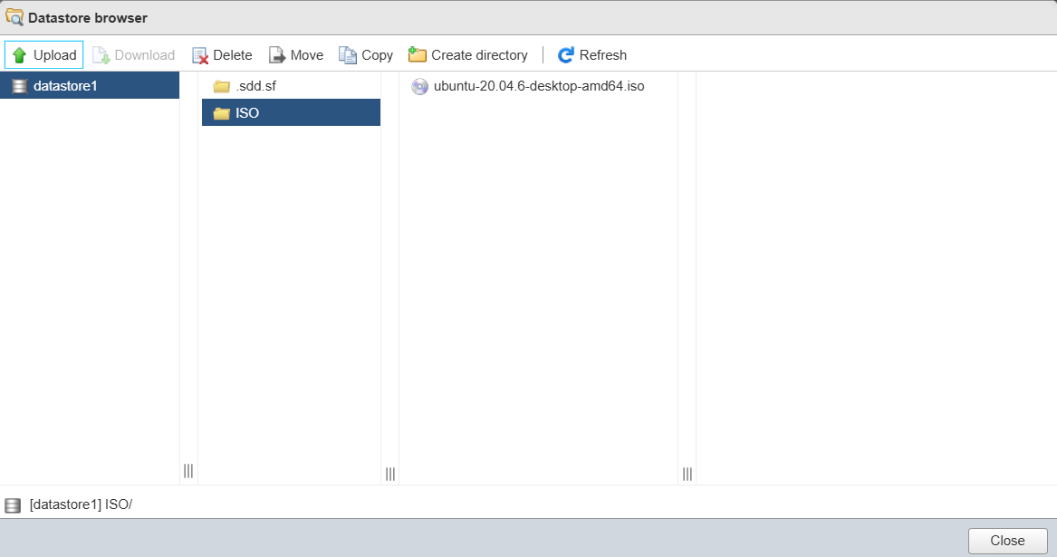
12. Part G — Create the Ubuntu Virtual Machine
Step 1: Create a New VM
From the ESXi Host Client:
- Select Virtual Machines.

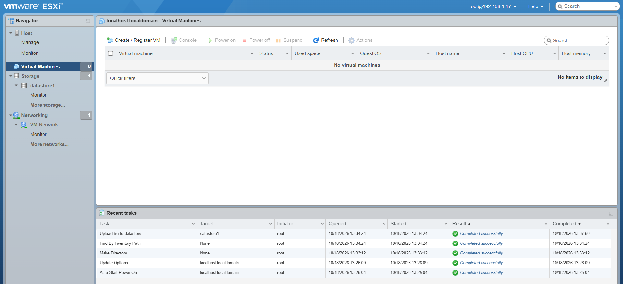
- Click Create / Register VM.
- Select:
Create a new virtual machine
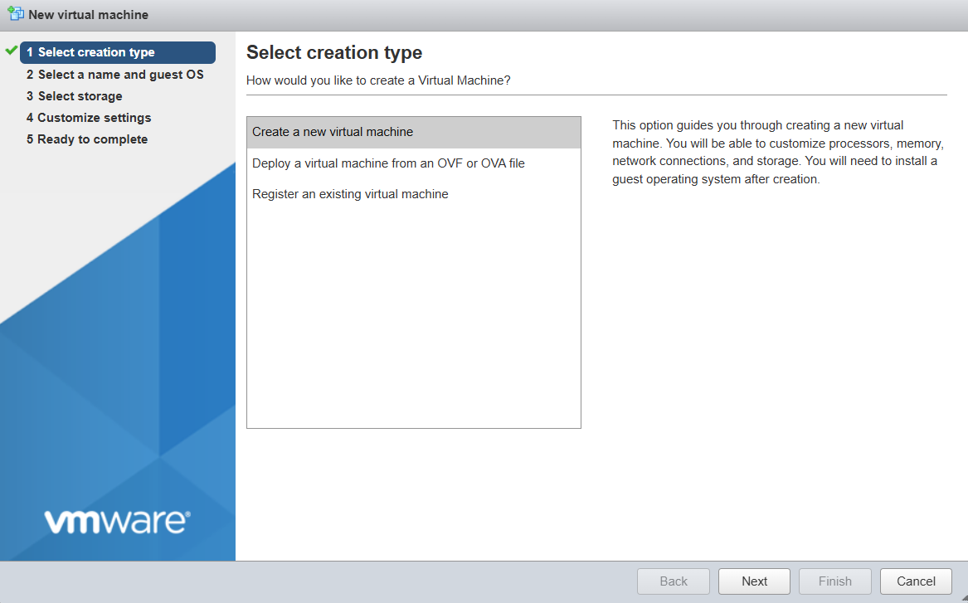
- Click Next.

13. Step 2 — Configure VM Name and Guest OS
Enter the VM information.
Example:
Setting | Value
VM Name | Ubuntu-20.04-Desktop
Compatibility | Default available option
Guest OS Family | Linux
Guest OS Version | Ubuntu/Linux 64-bit appropriate for the selected ESXi version
Click Next.
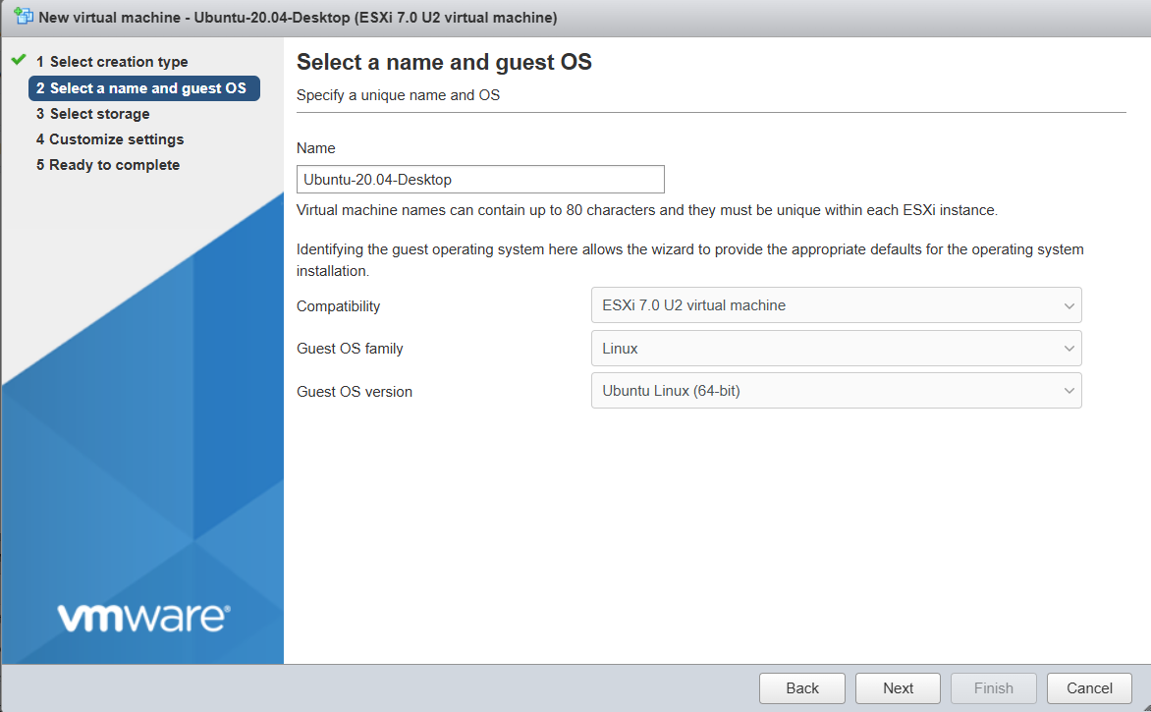
14. Step 3 — Select Datastore
Select the datastore where the VM will be stored.
Example:
datastore1
Click Next.

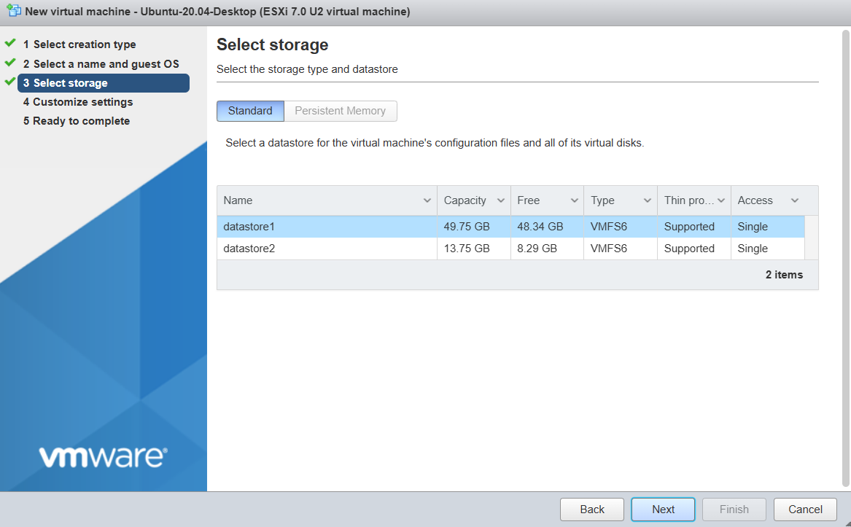
15. Step 4 — Configure VM Hardware
Configure the virtual hardware.
A suitable lab configuration could be:
Resource | Configuration
CPU | 2 vCPU
Memory | 4 GB
Hard Disk | 40 GB
Network Adapter | VM Network
CD/DVD Drive | Ubuntu ISO
The actual values should be adjusted according to the available resources of the ESXi host.

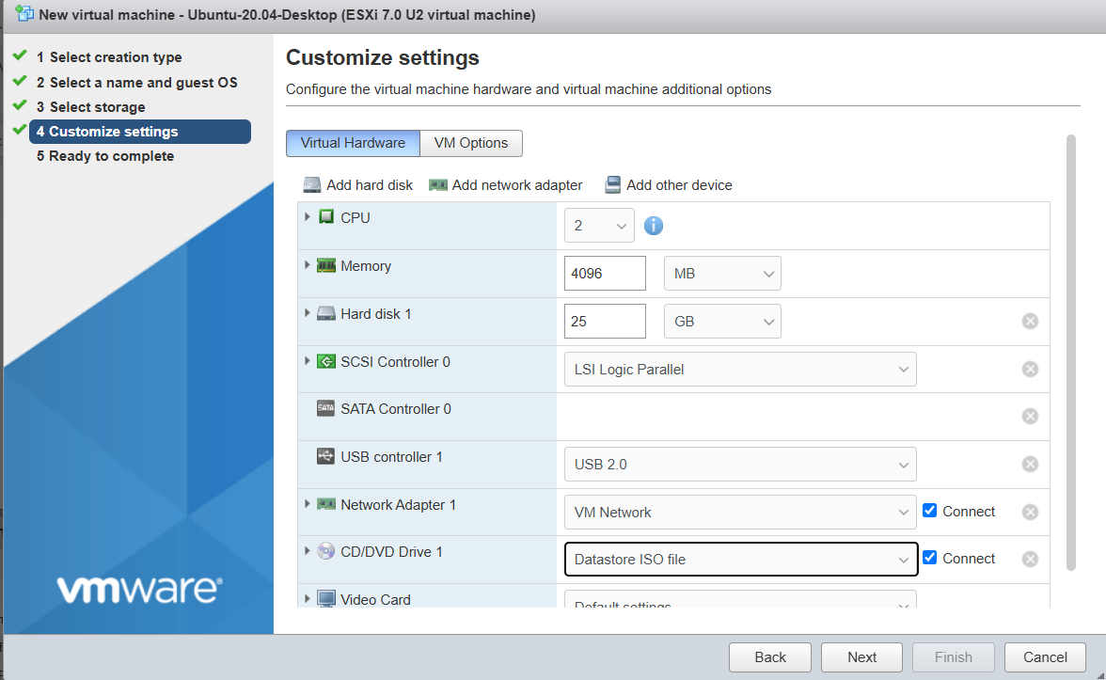
16. Step 5 — Configure Virtual Hard Disk
Configure the VM's virtual disk.
Example:
Disk Size: 40 GB
Disk Provisioning: Thin Provision
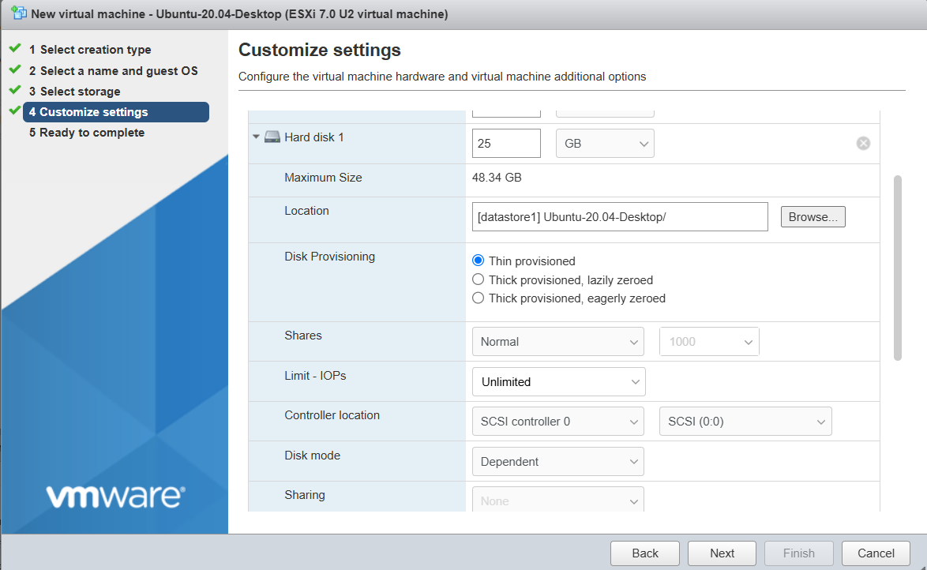
A thin-provisioned virtual disk initially consumes storage according to the actual data written to it and can grow as needed, subject to datastore capacity.

17. Step 6 — Configure Network Adapter
Select the appropriate virtual network.
Example:
Network: VM Network
Ensure that the virtual network is connected.
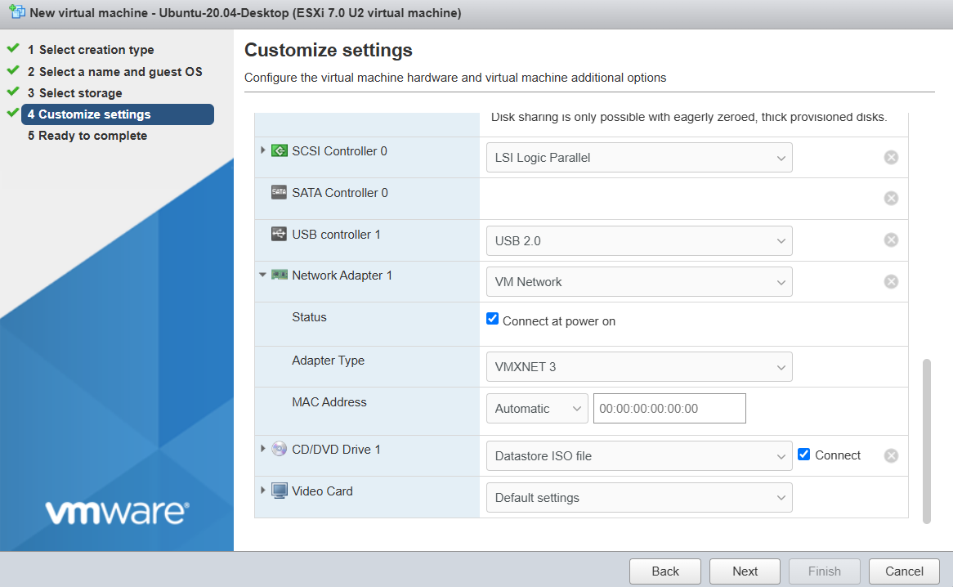
The VM will use this virtual network adapter to communicate with the network.

18. Step 7 — Connect the Ubuntu ISO
Configure the VM's virtual CD/DVD drive.
Select:
CD/DVD Drive
↓
Datastore ISO File
↓
ISO/
ubuntu-20.04.6-desktop-amd64.iso
Enable:
Connect
and, if available, configure it to connect when the VM powers on.
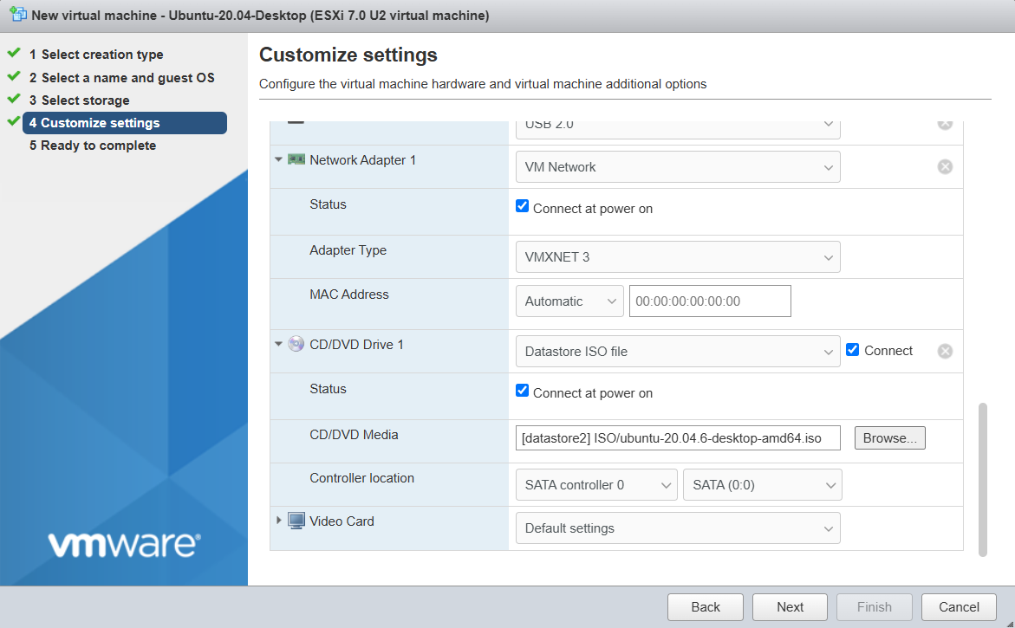
19. Step 8 — Review and Create the VM
Review the configuration.
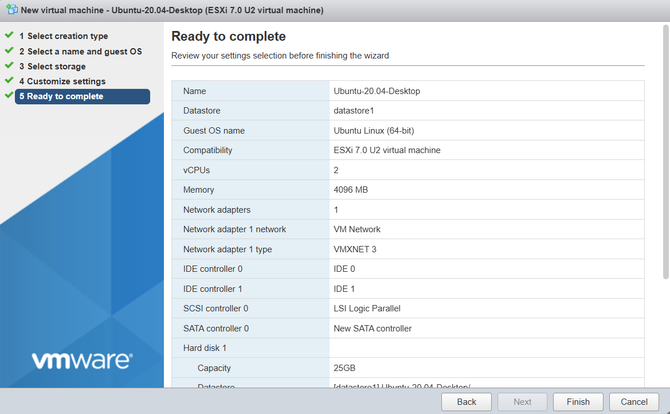
Click Finish.
The VM is now created.

20. Part H — Power On the VM
Step 1: Select the VM
From Virtual Machines, select:
Ubuntu-20.04-Desktop

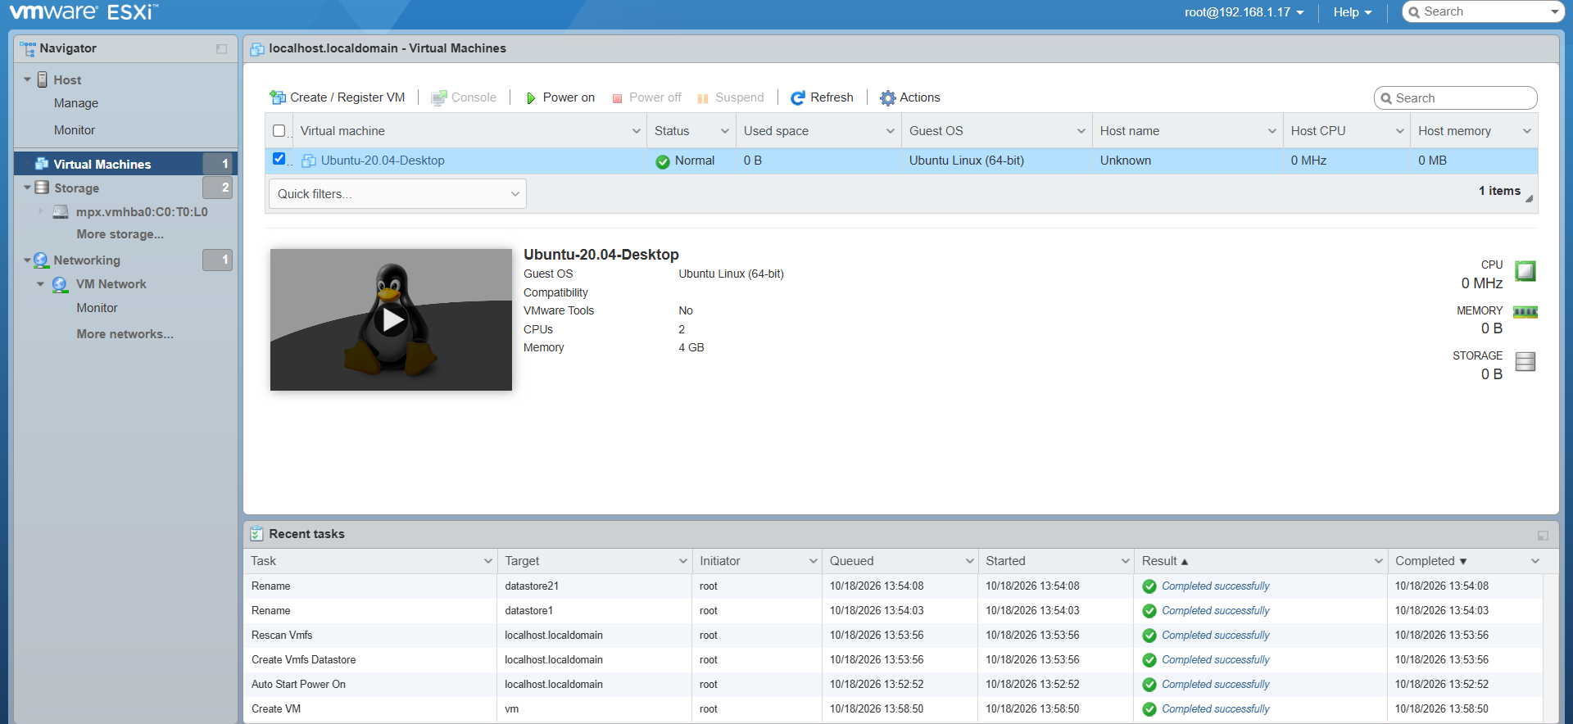
Step 2: Power On
Click:
Power On
The VM starts.
21. Part I — Install Ubuntu 20.04.6 Desktop
Open the VM console.
The VM should boot from:
ubuntu-20.04.6-desktop-amd64.iso
The Ubuntu installer appears.
Follow the Ubuntu installation wizard.
Typical steps include:
- Select language.

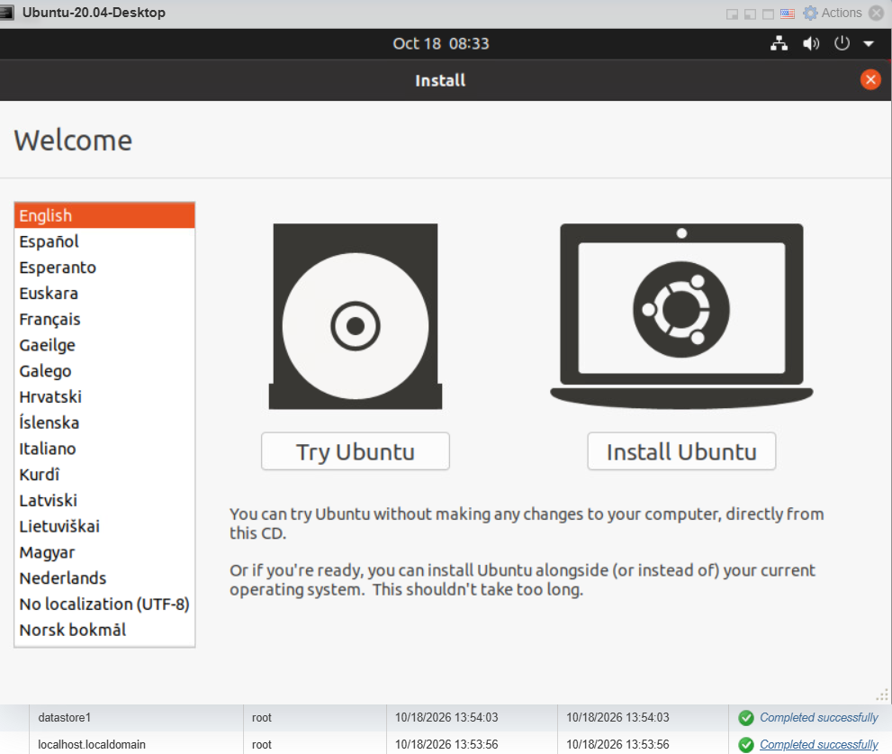
- Select keyboard layout.
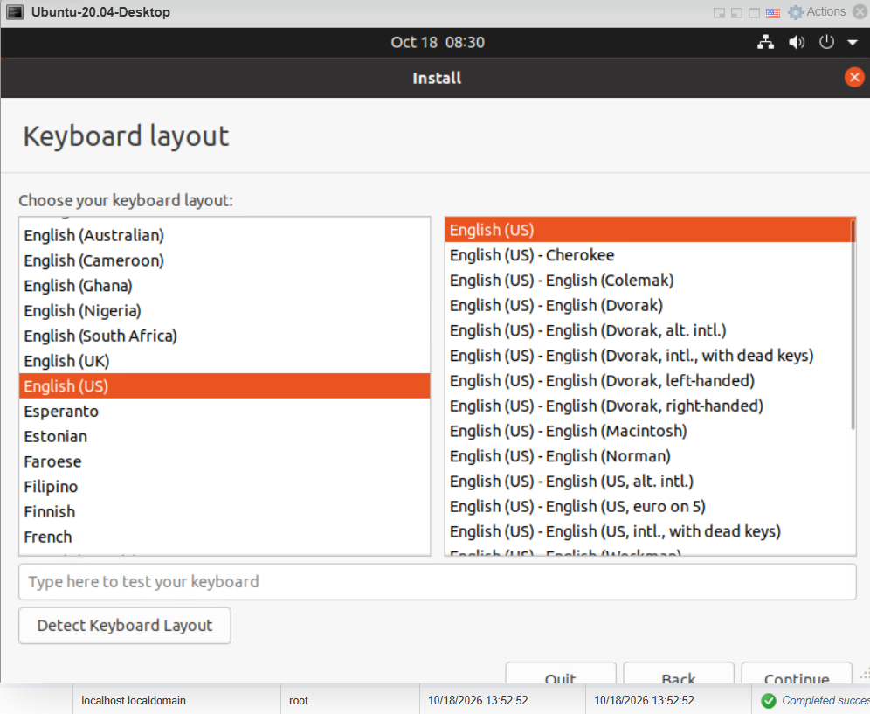
- Select installation type.
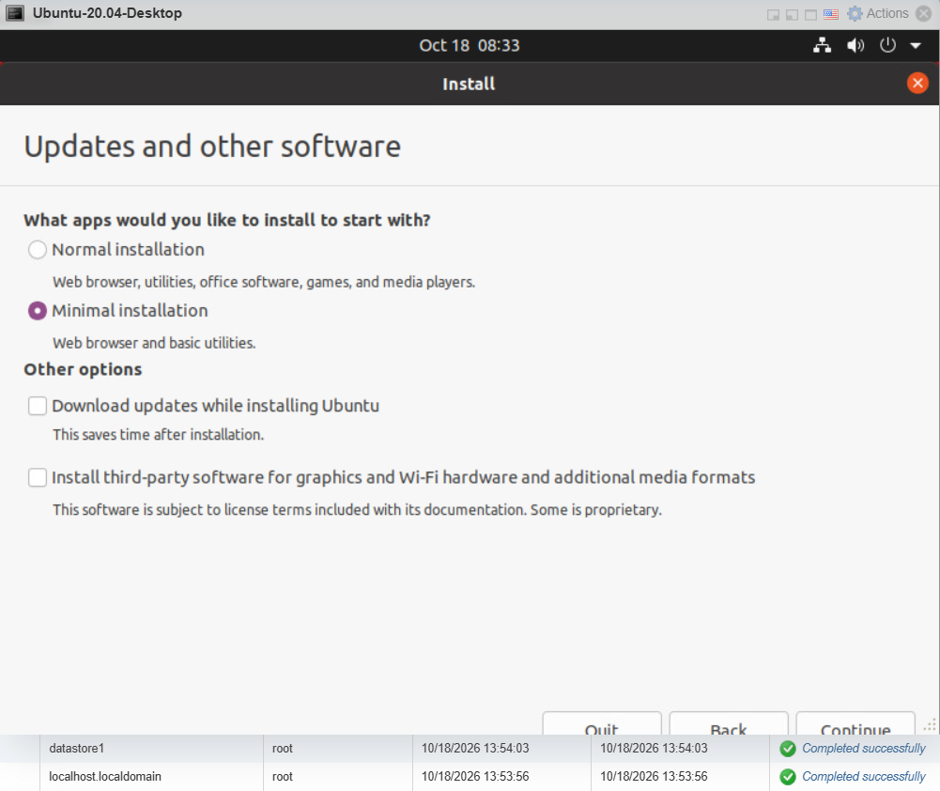
- Select Erase Disk and install Ubuntu.
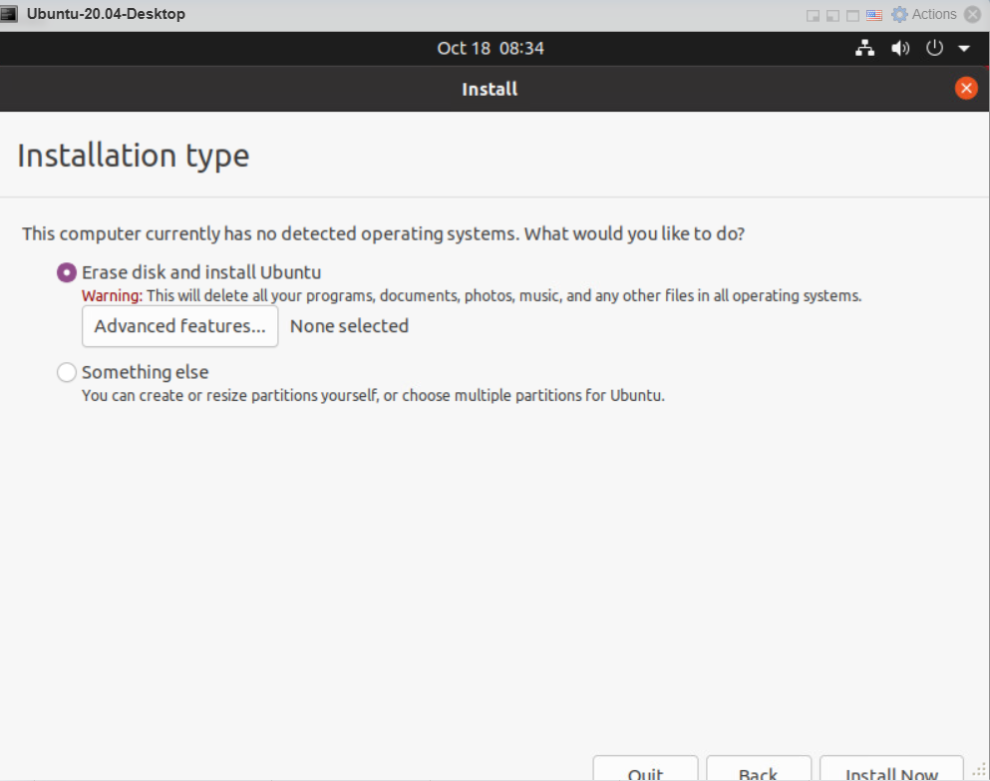
- Set the time zone.
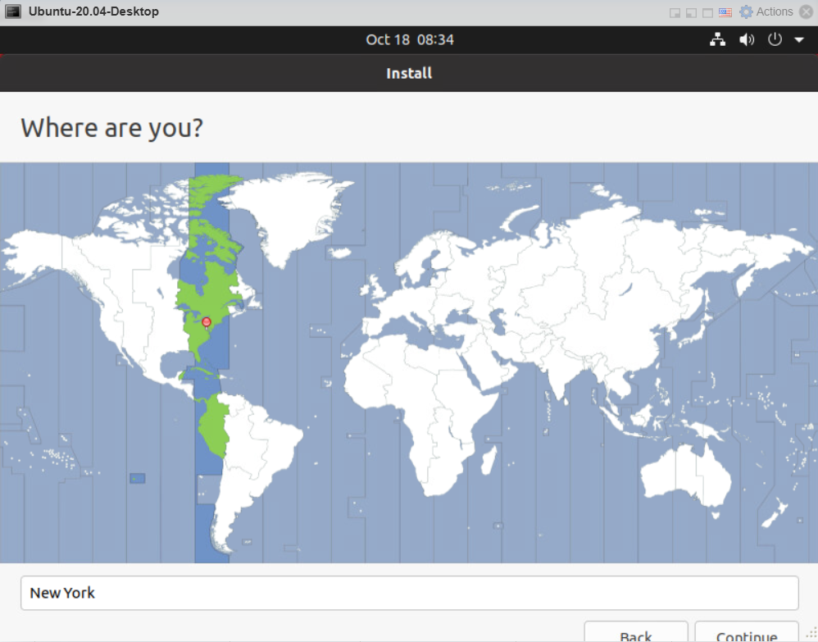
- Configure user account.
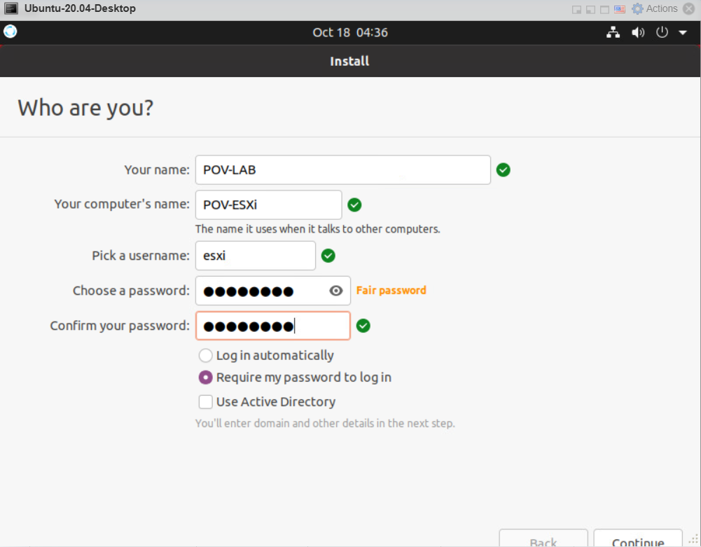
- Start the installation.
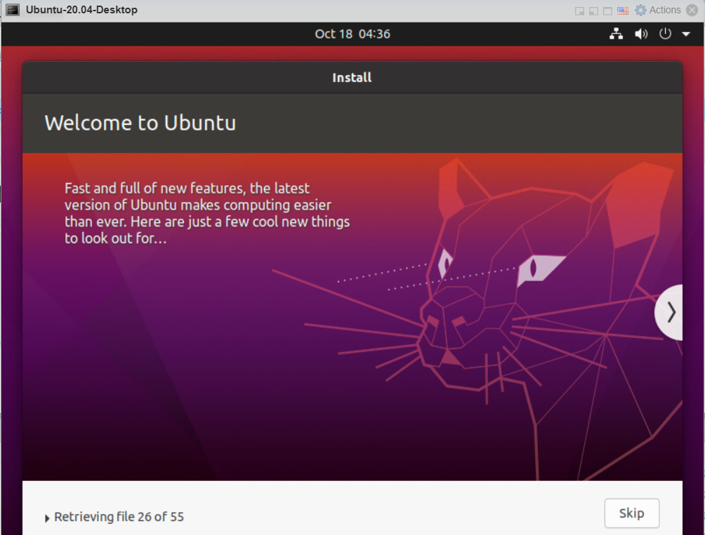
- Wait for installation to complete.
- Restart the VM when prompted.
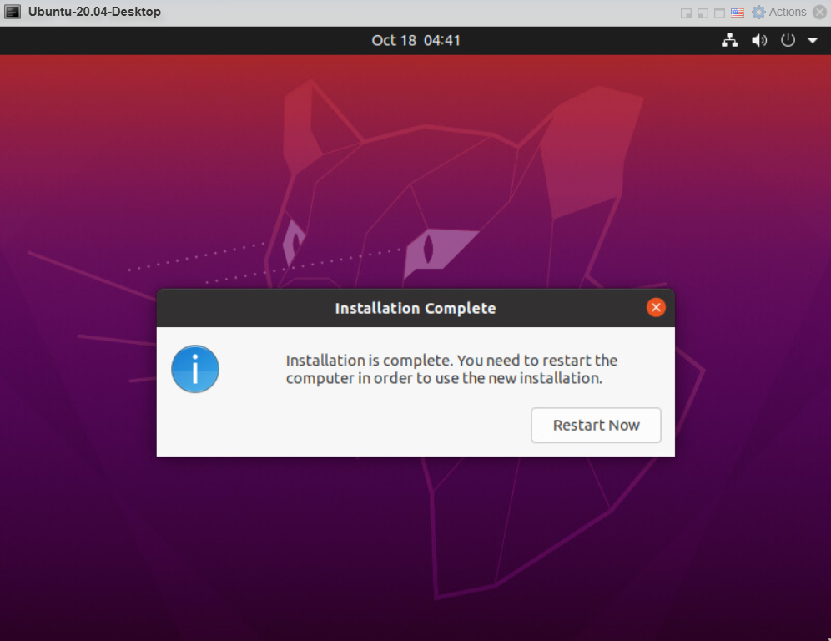
After restarting, disconnect/eject the ISO if necessary so that the VM boots from its virtual hard disk.
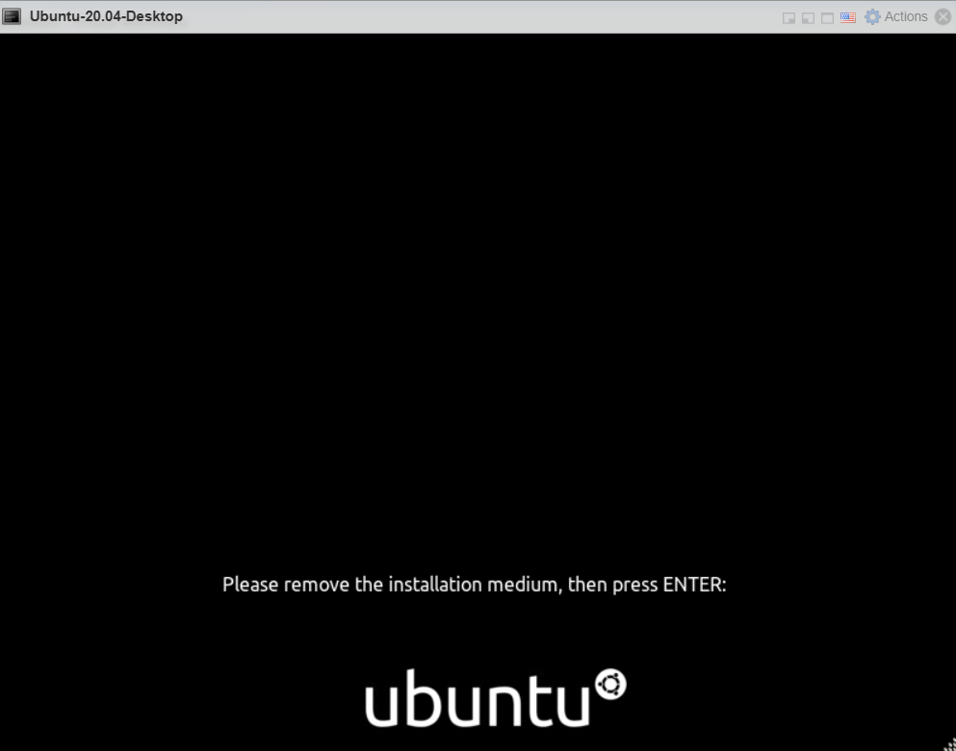
22. Part J — Verify the Ubuntu Virtual Machine
After Ubuntu starts, verify the following:
- Ubuntu boots successfully.
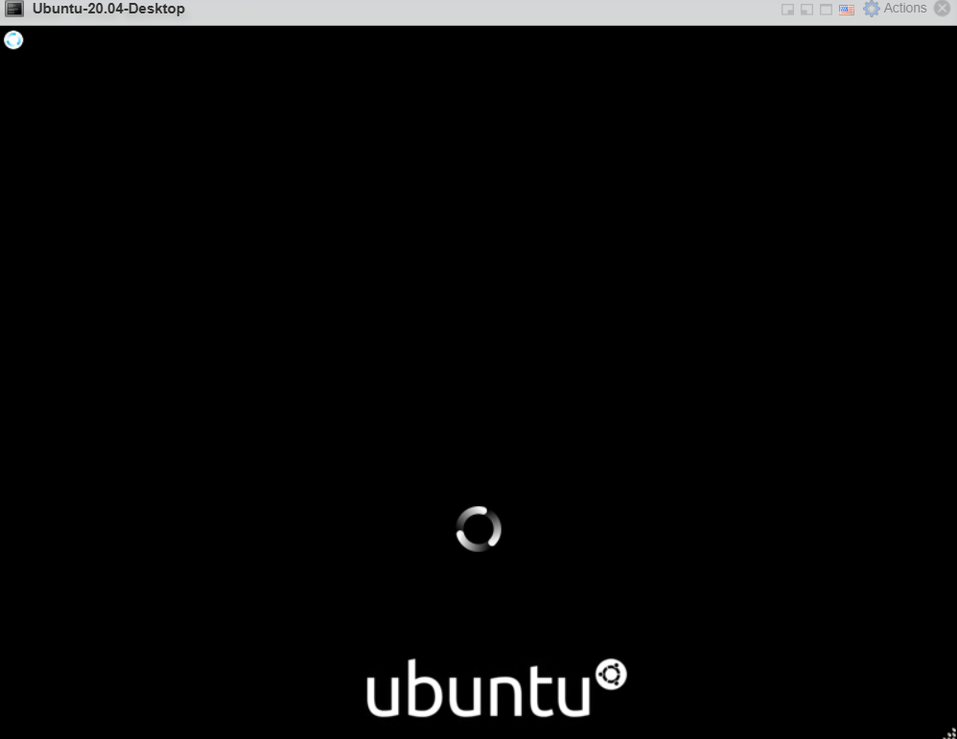

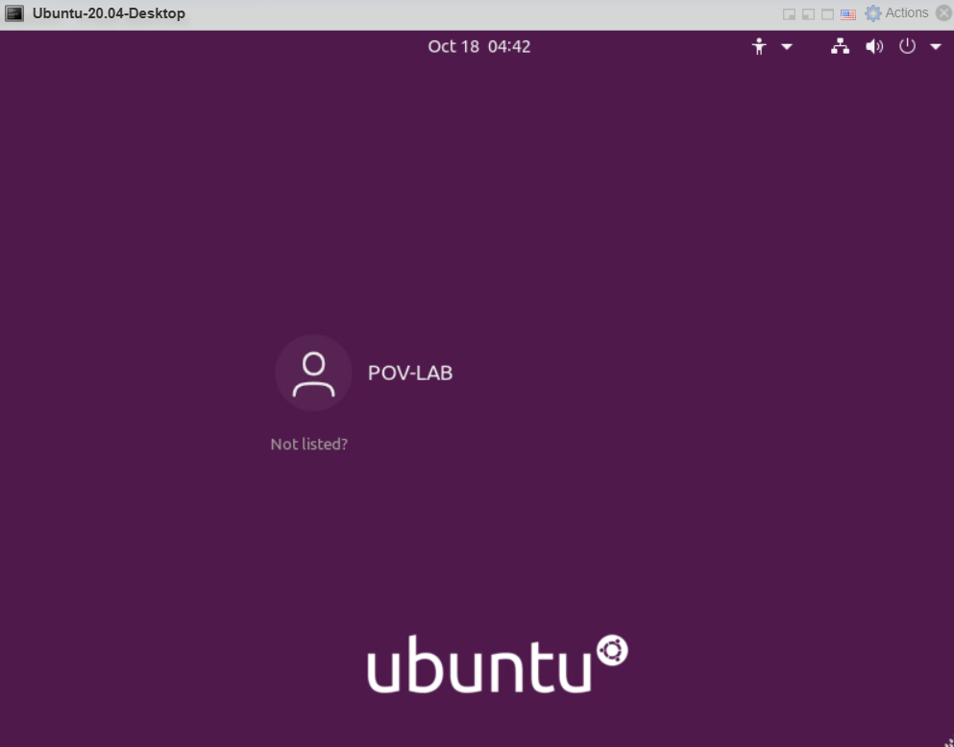

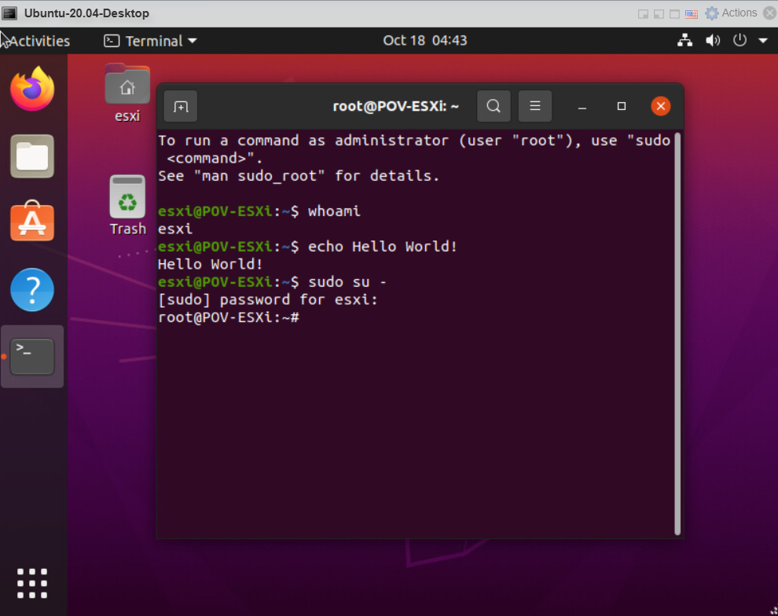
- The VM has the expected amount of memory.
- The VM has the expected number of virtual CPUs.
- The virtual hard disk is detected.

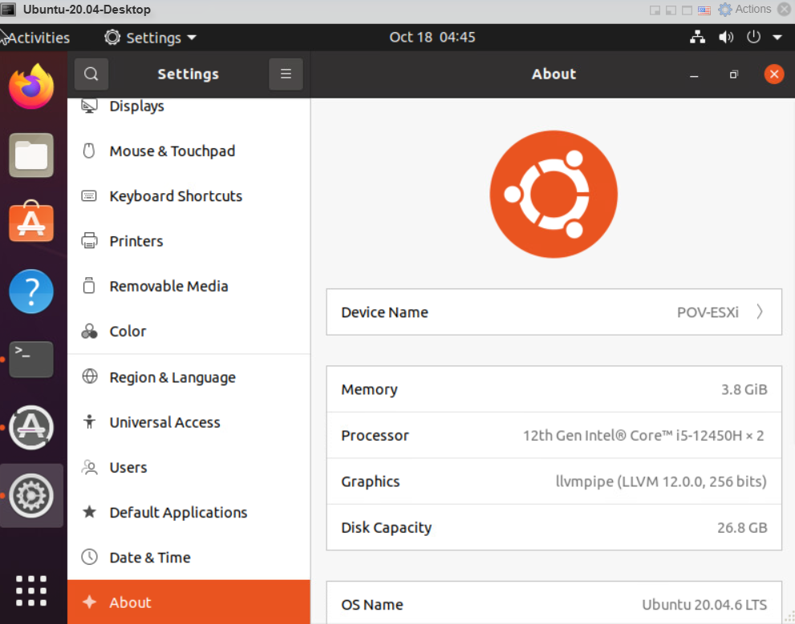
- The network adapter is detected.
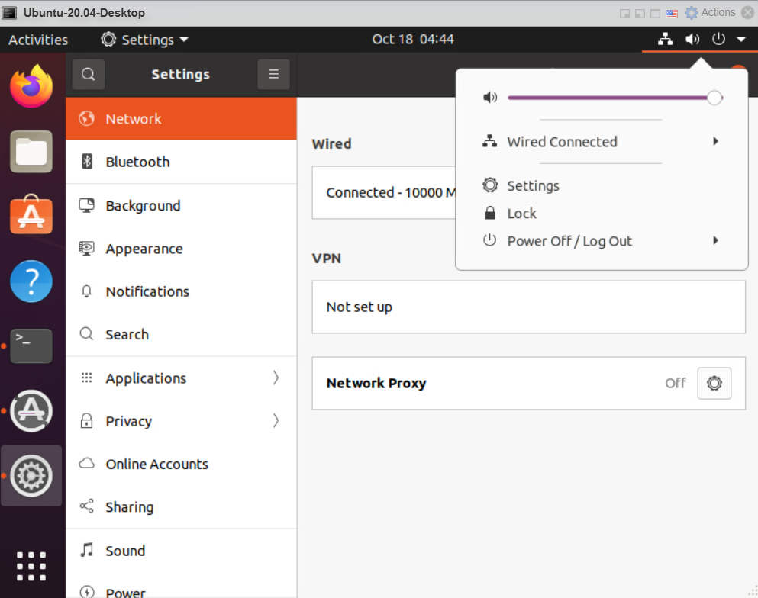
- Network connectivity works if a suitable network is configured.
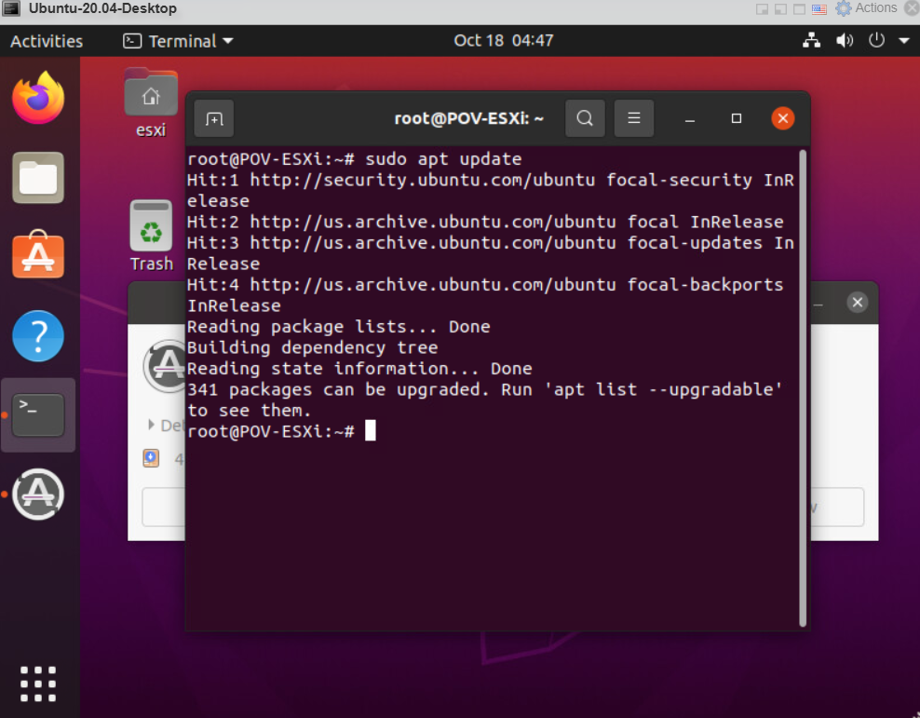
- The VM appears as Powered On in the ESXi Host Client.

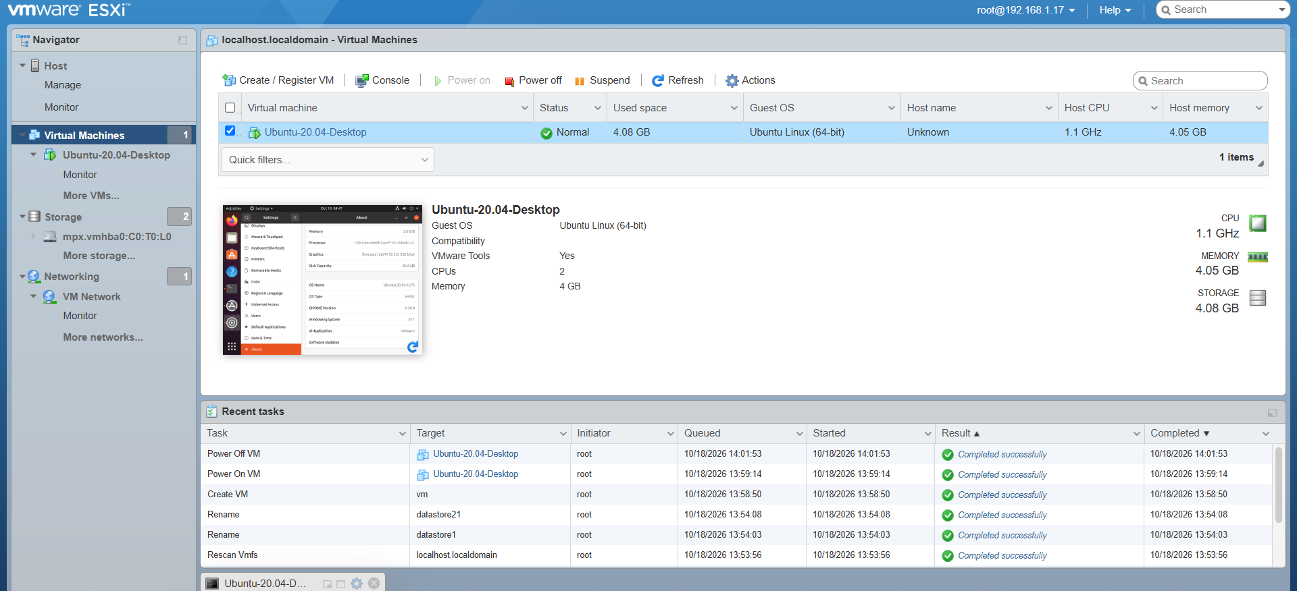

24. Conclusion
In this practical, the basic components of VMware vSphere were studied, including ESXi and vCenter Server. VMware ESXi was installed and configured as the virtualization host, and its web-based Host Client was accessed from Windows 11.
The Ubuntu 20.04.6 Desktop ISO was uploaded to the ESXi datastore and used to create a new Virtual Machine. The VM was configured with CPU, memory, virtual disk, and network resources. After powering on the VM, Ubuntu was installed as the guest operating system.
The practical demonstrated the complete basic workflow of creating and running a virtual machine on a VMware ESXi server.

